**IFT 598 – Data Visualization & Reporting for IT**

**Project- Phase 3: Dashboard implementation**

**Rishikesh Manohar**

**Aiman Sara Sheikh  
Kevin Patel  
Ganesh Matte**

**Instructor- Asmaa Elbadrawy**

**23rd April, 2023**

**Section 1: The Dashboard**

In essence, a dashboard is a tool that enables customers to immediately comprehend the status of their company or project by presenting data in a simplified and visual form. Key performance indicators (KPIs) and goal-tracking are often monitored by businesses, organizations, and people.

Dashboards frequently use numerous software systems, including databases, spreadsheets, and others, to gather data. After that, the data is transformed and presented in a way that makes it simple to understand and analyze. To do this, information may be presented visually through the use of graphs, tables, charts, and other features.

Dashboards allow users to recognize patterns, uncover anomalies, and make educated decisions by giving an overview of key data elements. For instance, a sales team may utilize a dashboard to analyze sales leads, keep tabs on monthly income, and assess the effectiveness of individual team members. Similar to this, a project manager may utilize a dashboard to keep tabs on budget spending, monitor project milestone progress, and spot possible dangers.

Overall, dashboards are an effective tool for anyone who wants to monitor large data sets and make data-driven choices. They can save consumers time and effort by providing information in an understandable manner and offer insightful data on the state of a business or project.

**Name of the Final Dashboard Implemented: World Happiness Report Analysis**

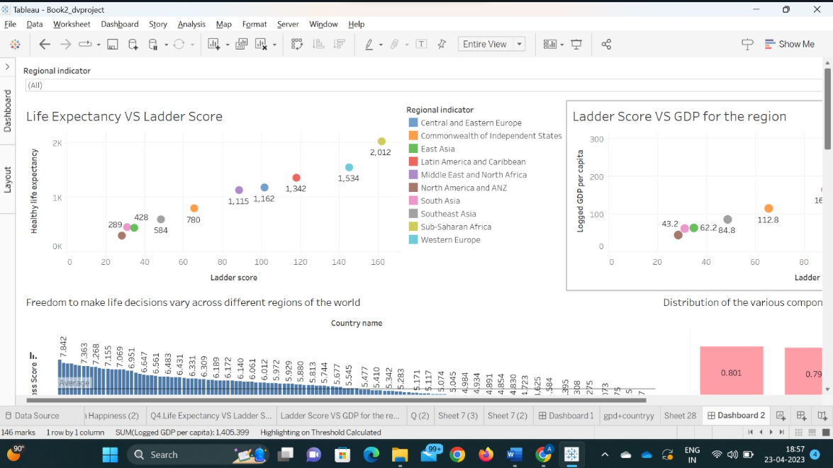

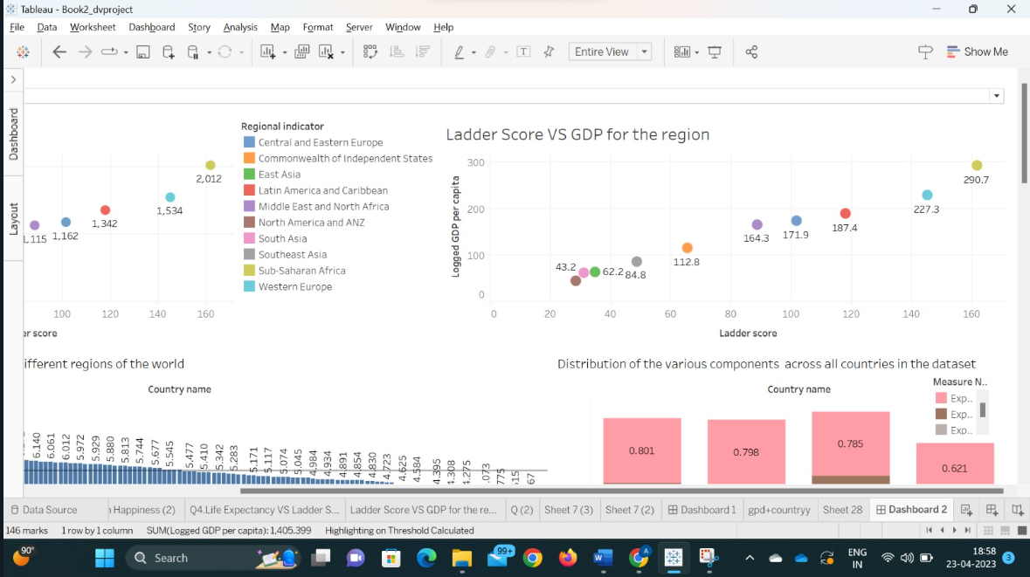

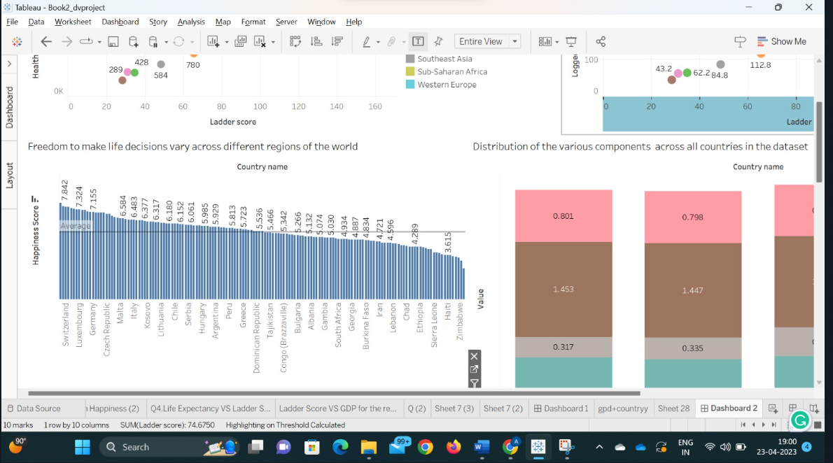

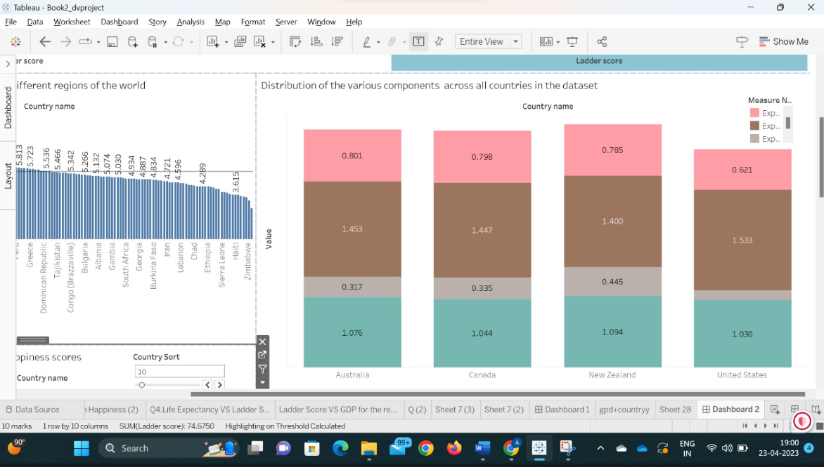

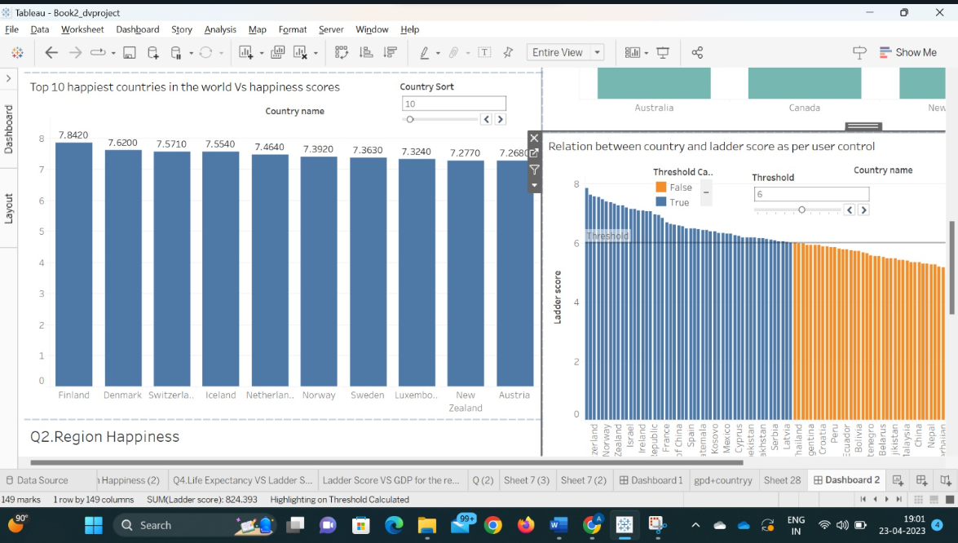

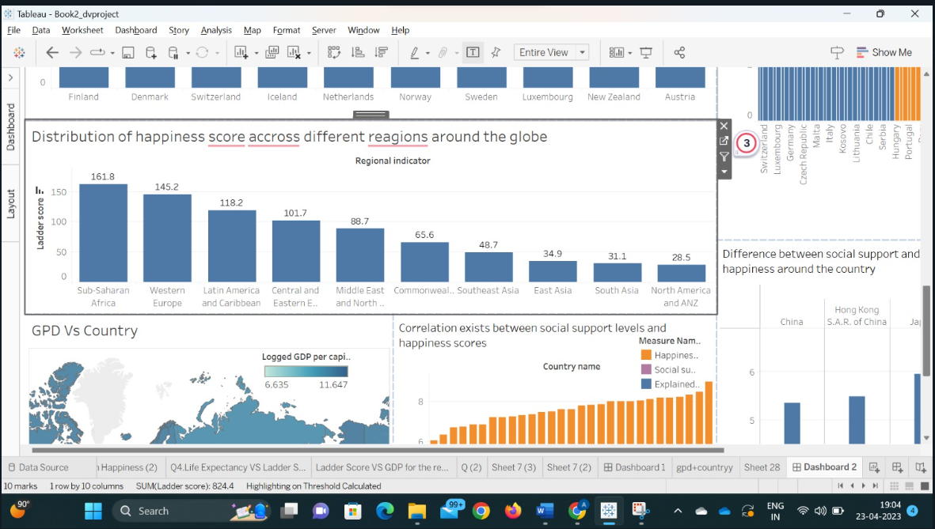

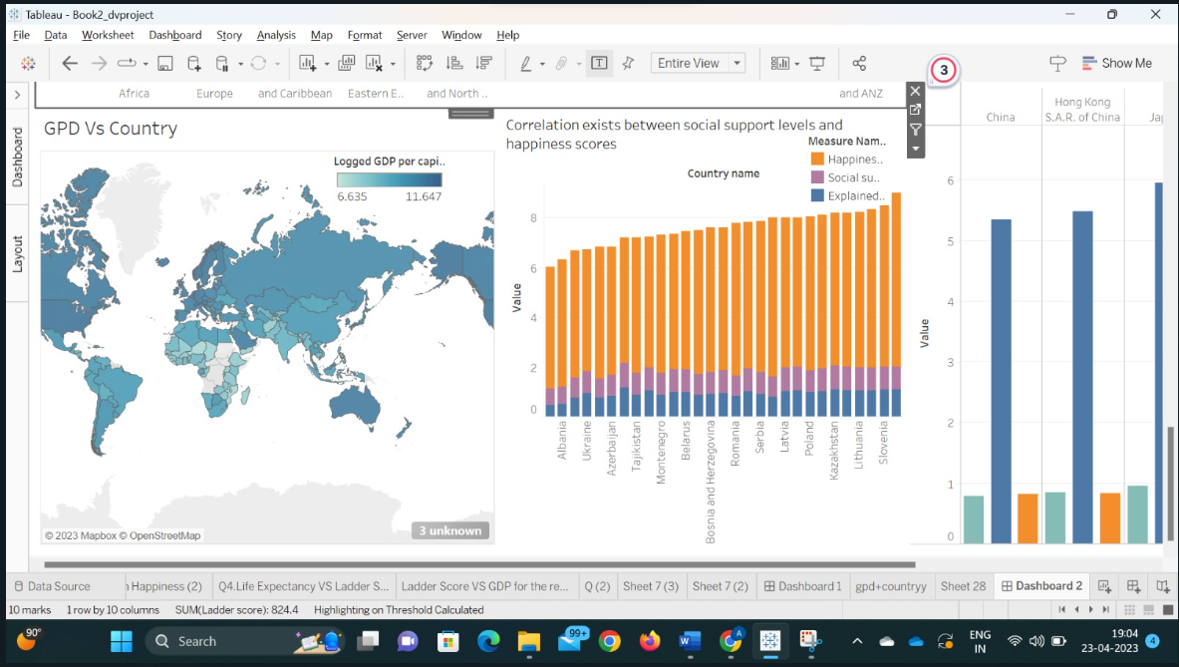

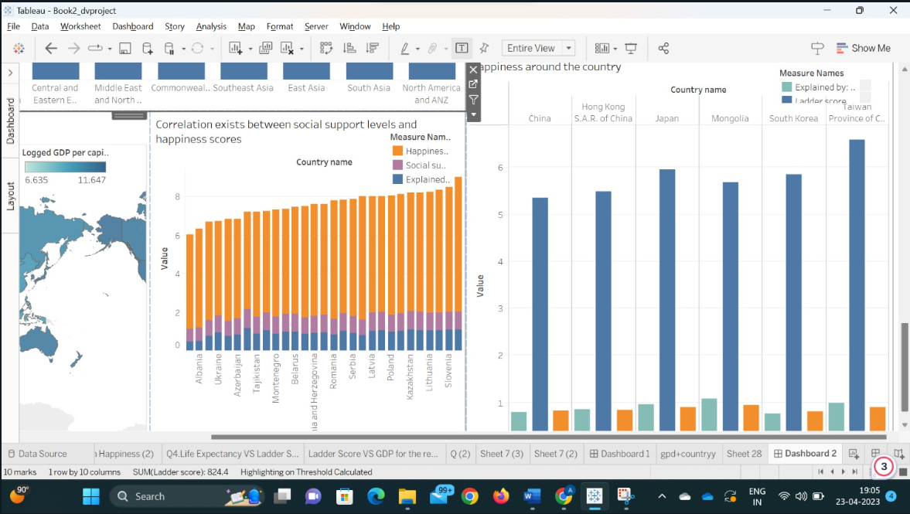

**Usage of this dashboard:**

The World Happiness Report dashboard may be used to construct an information that offers an overview of worldwide happiness levels and highlights significant elements that contribute to happiness.

A dashboard based on this dataset may include numerous visualizations, such as a map displaying the average happiness scores of nations throughout the world. This allows users to rapidly discover areas that are particularly joyful or sad.

A scatterplot illustrating the association between happiness and other characteristics such as money, social support, and life expectancy. This can assist users in determining which elements have the strongest association with happiness.

A bar chart displaying the top countries in terms of happiness, as well as their ratings for each of the important variables. This can assist people understand what makes these countries so joyful.

A line graph depicting the changes in happiness levels for distinct nations throughout time. This can assist consumers understand how happiness levels have varied across different locations.

By integrating these representations, viewers may acquire a thorough picture of global happiness levels and discover crucial elements that contribute to happiness. This data may be utilized by politicians, organizations, and individuals to make decisions that promote higher happiness and well-being.

**SECTION 2: THE DATASET**

**Dataset Description:**

**“**

The World Happiness Index is a comprehensive dataset that provides information on global happiness levels and the factors that contribute to the happiness of people living in different countries.

The report includes the happiness scores and rankings of countries, which are measured on a scale from 0 to 10, with 10 representing the highest level of happiness. In addition to the happiness scores, the report estimates how six different factors contribute to making life evaluations higher in each country. These factors include economic production, social support, life expectancy, freedom, absence of corruption, and generosity.

The economic production factor refers to the country's Gross Domestic Product (GDP) per capita, which is the value of all goods and services produced within the country in a year divided by the population. The social support factor measures the perceived social support provided by family, friends, and other social networks. Life expectancy is an estimate of the number of years a person can expect to live in good health based on the country's health care system and other factors.

Freedom refers to the perceived freedom to make life choices, such as the ability to choose one's own job or pursue education. Absence of corruption measures the extent to which public officials and institutions are perceived to be corrupt. Finally, the generosity factor measures the perceived generosity of the population, including charitable donations and volunteering.

The report is authored by experts in various fields, including psychology, economics, and public policy, and it provides an in-depth analysis of the data to explain why some countries rank higher than others in terms of happiness. The report aims to inform policy-making decisions at the national and international levels and promote well-being and happiness around the world.

# Row and column counts:

There are 150 data points (rows) and 20 attributes (Columns) in the World Happiness report

**”**

**Specification of Data Types for a column:**

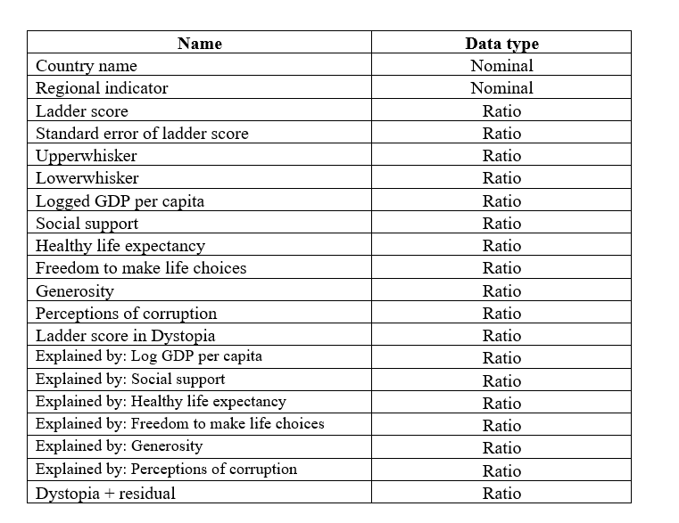

“

**Description of an attribute:**

* **Country name** : The name of the country being evaluated in the happiness index.
* **Regional Indicator**: The regional classification of the country, according to the United Nations geosphere.
* **Ladder score:** The happiness score assigned to the country on a scale of 0 to 10, with 10 being the happiest.
* **Standard error of ladder score:** The margin of error associated with the ladder score.
* **Upper whisker:** The highest score within 1.5 times the interquartile range (IQR) above the third quartile.
* **Lower whisker :** The lowest score within 1.5 times the IQR below the first quartile.
* **Logged GDP per capita :** The natural logarithm of the country's Gross Domestic Product (GDP) per capita in international dollars, adjusted for purchasing power parity.
* **Social support :** The perceived level of social support available to individuals in the country
* **Healthy life expectancy:** The average number of years a person can expect to live in good health, based on data from the World Health Organization.
* **Freedom to make life choices:** The perceived level of freedom to make life choices in the country
* **Generosity:** The perceived level of generosity in the country
* **Perceptions of corruption :** The perceived level of corruption in the country
* **Ladder score in Dystopia :** The ladder score for a hypothetical country named Dystopia, used as a benchmark for comparison
* **Explained by: Log GDP per capita :** The extent to which the country's GDP per capita explains the ladder score
* **Explained by: Social support:** The extent to which social support explains the ladder score.
* **Explained by: Healthy life expectancy :** The extent to which healthy life expectancy explains the ladder score. Data type
* **Explained by: Freedom to make life choices:** The extent to which freedom to make life choices explains the ladder score
* **Explained by: Generosity:** The extent to which generosity explains the ladder score
* **Explained by: Perceptions of corruption:** The extent to which perceptions of corruption explain the ladder score.
* **Dystopia + residual:** A score based on the extent to which the country differs from the hypothetical country Dystopia.

”

**Data Pre-processing:**

**“**

Processing data is a crucial component of any analytical endeavor, as it necessitates manipulating and converting raw data into a format that is both understandable and visually appealing. Ensuring that the data is in the correct data type is a vital element of data processing, as it can impact the accuracy and effectiveness of the analysis.

As such, as part of our data processing efforts, we have taken the necessary steps to change the data type of the columns in our tableau dataset to their appropriate types. This ensures that the data is accurately represented and that we can perform effective analysis and visualization.

For instance, the data type of the column “Country Name” has been set to “String” type, and data type of the column “Happiness Score” has been set to “Number(decimal)”, which is shown in the screenshots below:

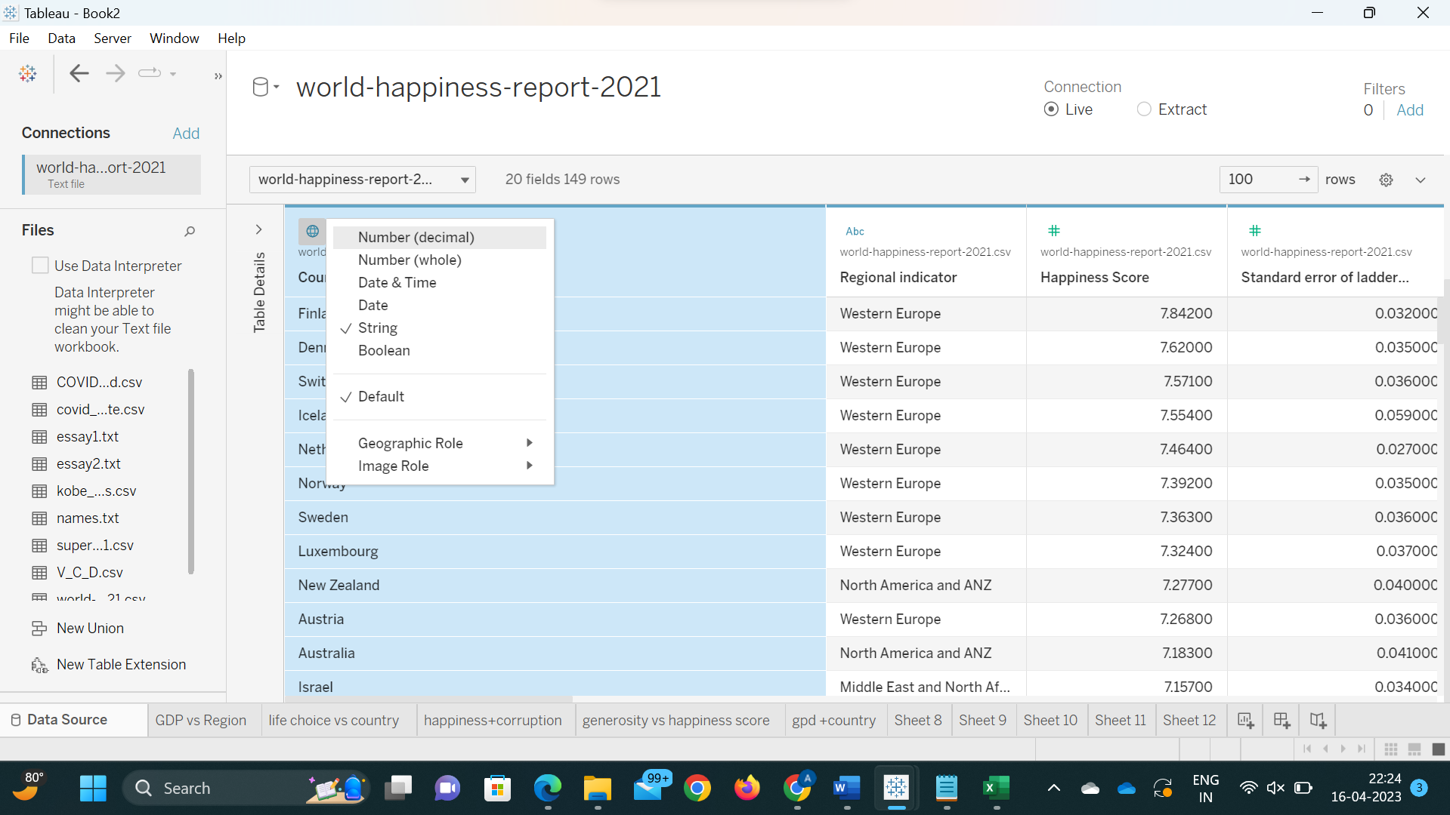

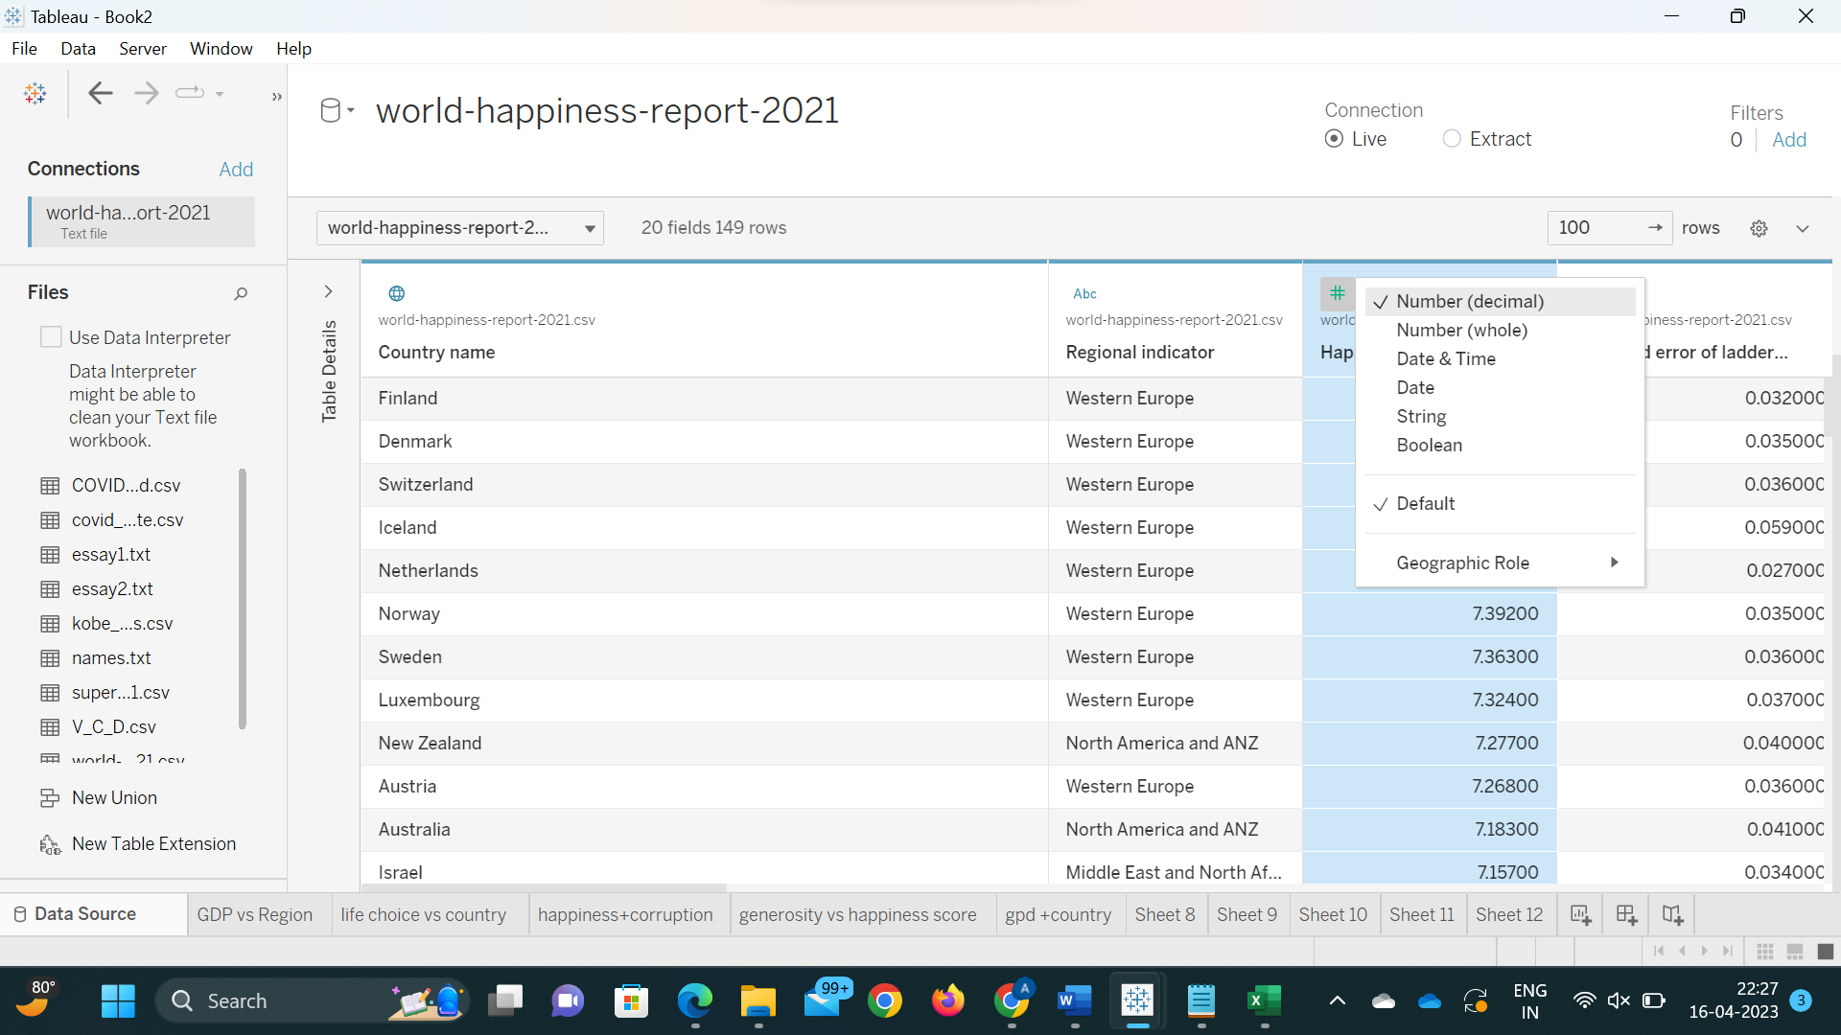

To accomplish this, we have utilized the powerful data manipulation capabilities of tableau, which allow us to easily convert data types from one format to another. By doing so, we have ensured that our data is clean, accurate, and easily interpretable, which is crucial for effective data analysis.

**”**

**SECTION 3: DASHBOARD USERS**

“

**This dataset's potential dashboard users include:**

**Application-making Business**

This dashboard is used by app development companies to determine the price of their app by analyzing similar apps. The price of the new app can be determined based on the reviews and ratings of similar apps.

**Data Analysts**:

This dashboard assists data analysts in determining the status of apps among Android users. This assists Google Play Store in comprehending the current Android market.

**Data Scientists:**

The number of installations is determined by data scientists based on application information and user reviews.

**Business Analysts:**

Data analysis is used by business analysts to generate a range of insights that guide decisions regarding products, such as "How can we improve the app?" like "What feature of the app do users like the most?"

**Neuroscientists and cognitive psychologists**

They may use the dataset to study the neural and cognitive processes that underlie happiness and well-being, and to develop new interventions to improve mental health and well-being.

**Public policy experts and political scientists**

who may use the dataset to evaluate the effectiveness of different policy interventions on improving the happiness and well-being of citizens?

**Social entrepreneurs and innovators**

who may use the dataset to identify opportunities to create new products, services, and social enterprises that address the well-being needs of different communities around the world?

**Journalists and media organizations**

who may use the dataset to report on trends and stories related to happiness and well-being around the world?

”

**SECTION 4: QUESTIONS**

1. Which are the top 10 happiest countries in the world and what are their happiness scores?
2. How are happiness scores distributed around the globe different in each region?
3. Correlation between happiness and GDP for that region.
4. Trend between life expectancy and happiness across different parts of the reason.
5. How does the amount of GDP per capita differ among different countries of the world?
6. Show the relation between country and ladder score as per user control.
7. How does the degree of Freedom to make life decisions vary across different regions of the world?
8. Difference between social support and explained by: social support along with happiness around the country?
9. What is the distribution of the various components (such as social support, GDP per capita, and so on) across all countries in the dataset?
10. What correlation exists between social support levels and happiness scores, and which nations have the greatest and lowest levels?

**SECTION 5: PLOTS**

Q1. Which are the top 10 happiest countries in the world and what are their happiness scores?

Answer: Bar graph is used to show the happiest country in the world, and we used the parameter and the calculated field which will help the user to find the top happiest country and make the visualization user friendly. Pre-attentive are length.

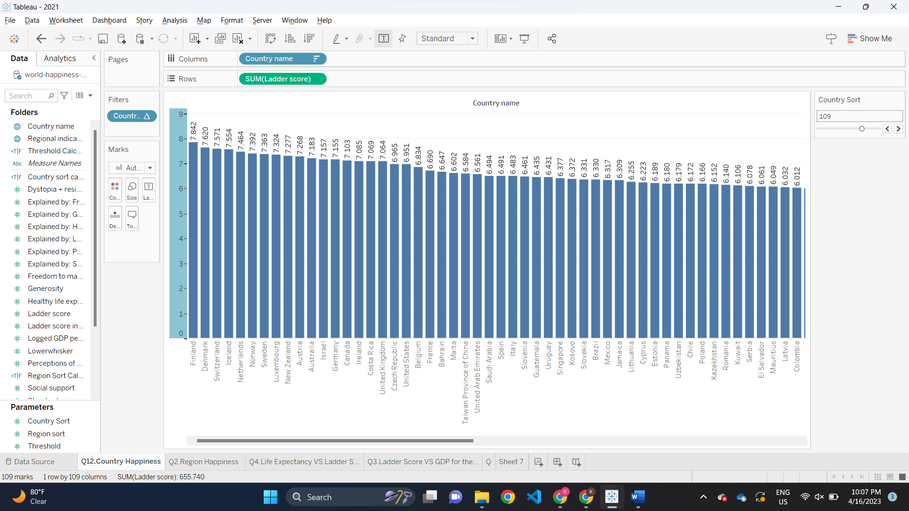

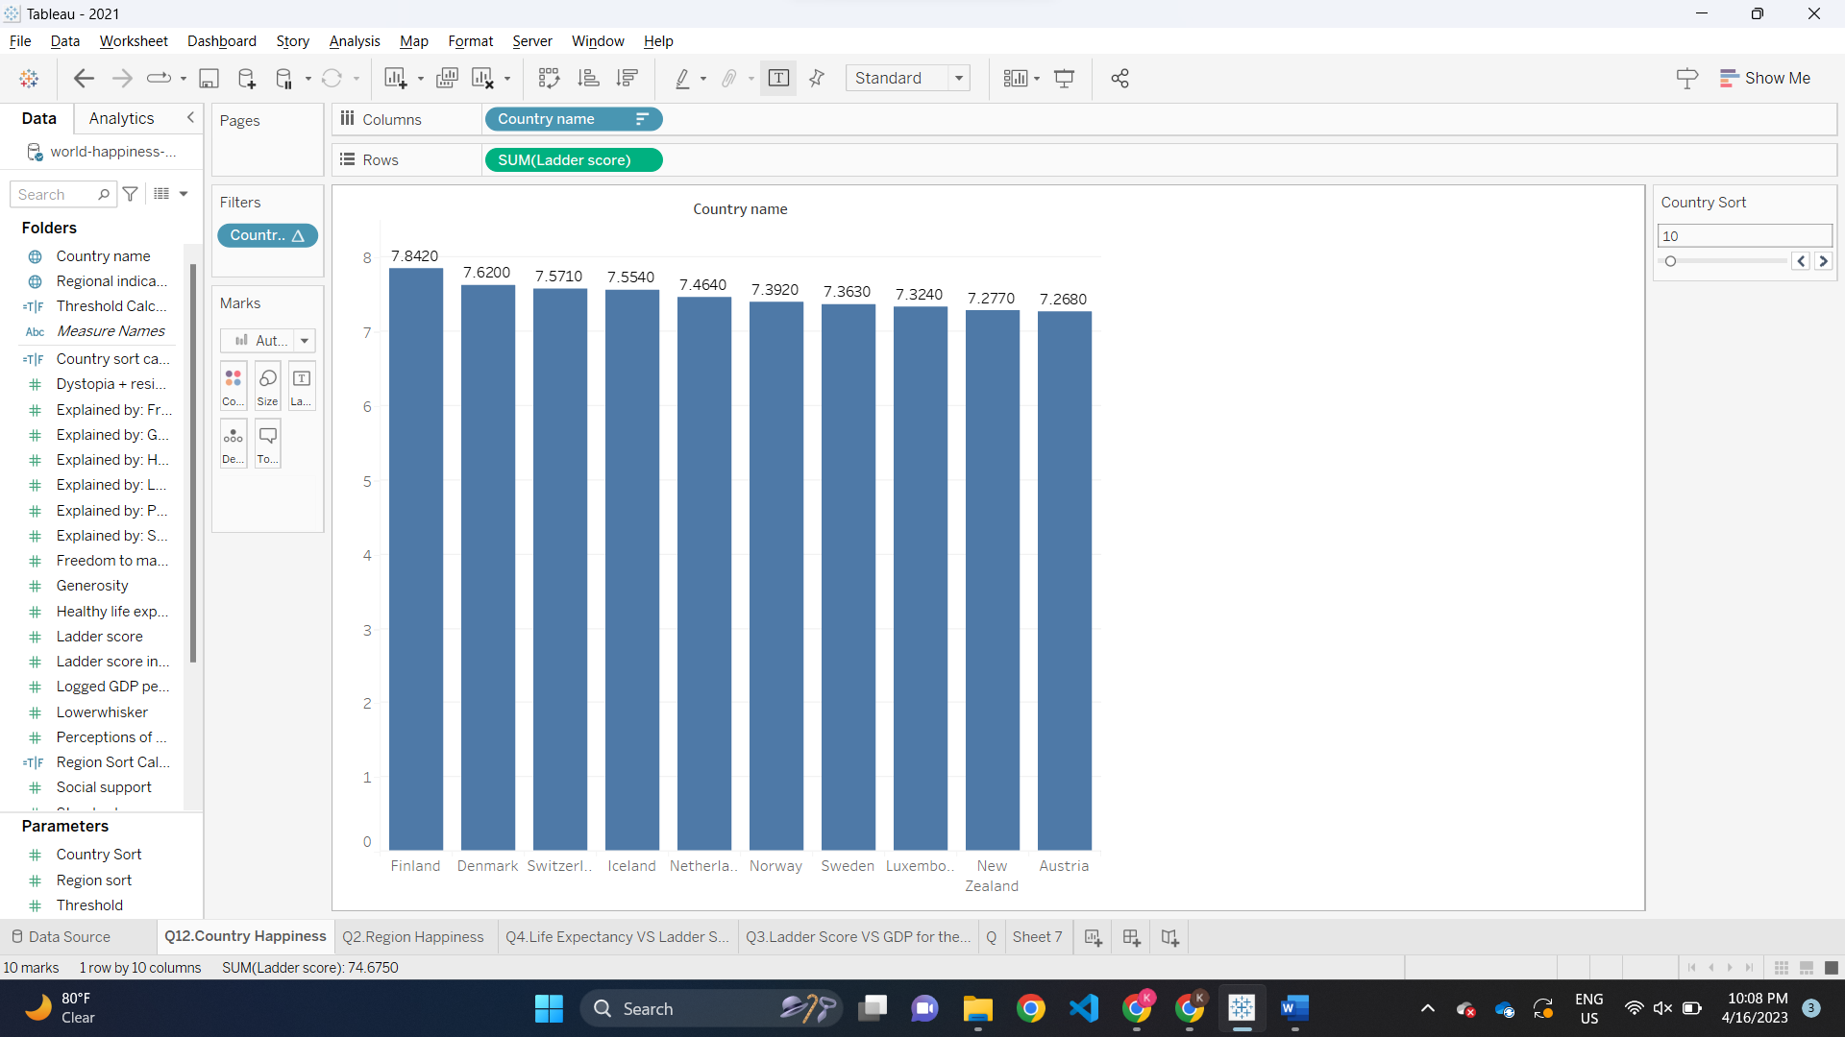

Q2. How are happiness scores distributed around the globe different in each region?

Answer: A bar graph is used to represent the happiness score of different regions around the globe.

Pre-attentive are length.

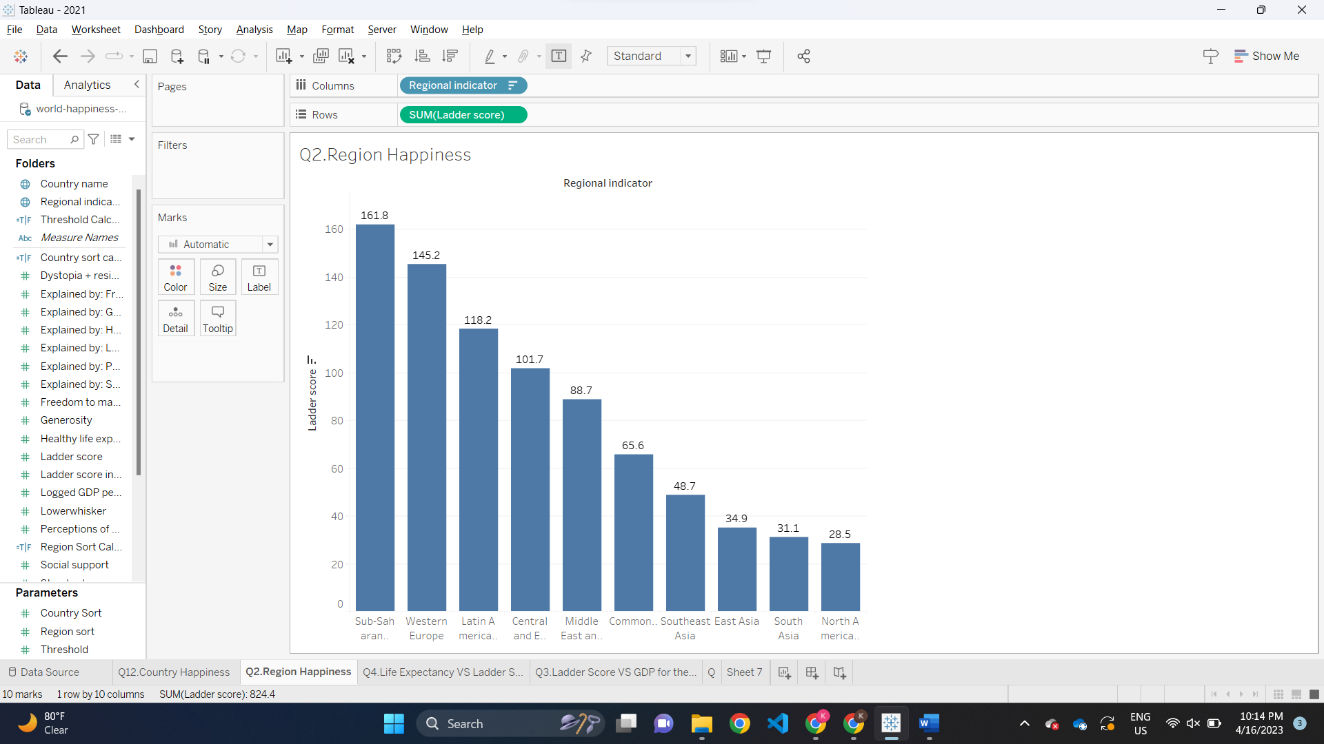

Q3.Correlation between happiness and GDP for that region.

Answer: A scatterplot is used to show the correlation between the happiness and the GDP for that region and the different color plots are used to define the different region of the globe. Here the y axis represents the happiness score whereas the x axis represents GDP per capita. Pre-attentive are size, shape(circle), color(hue).

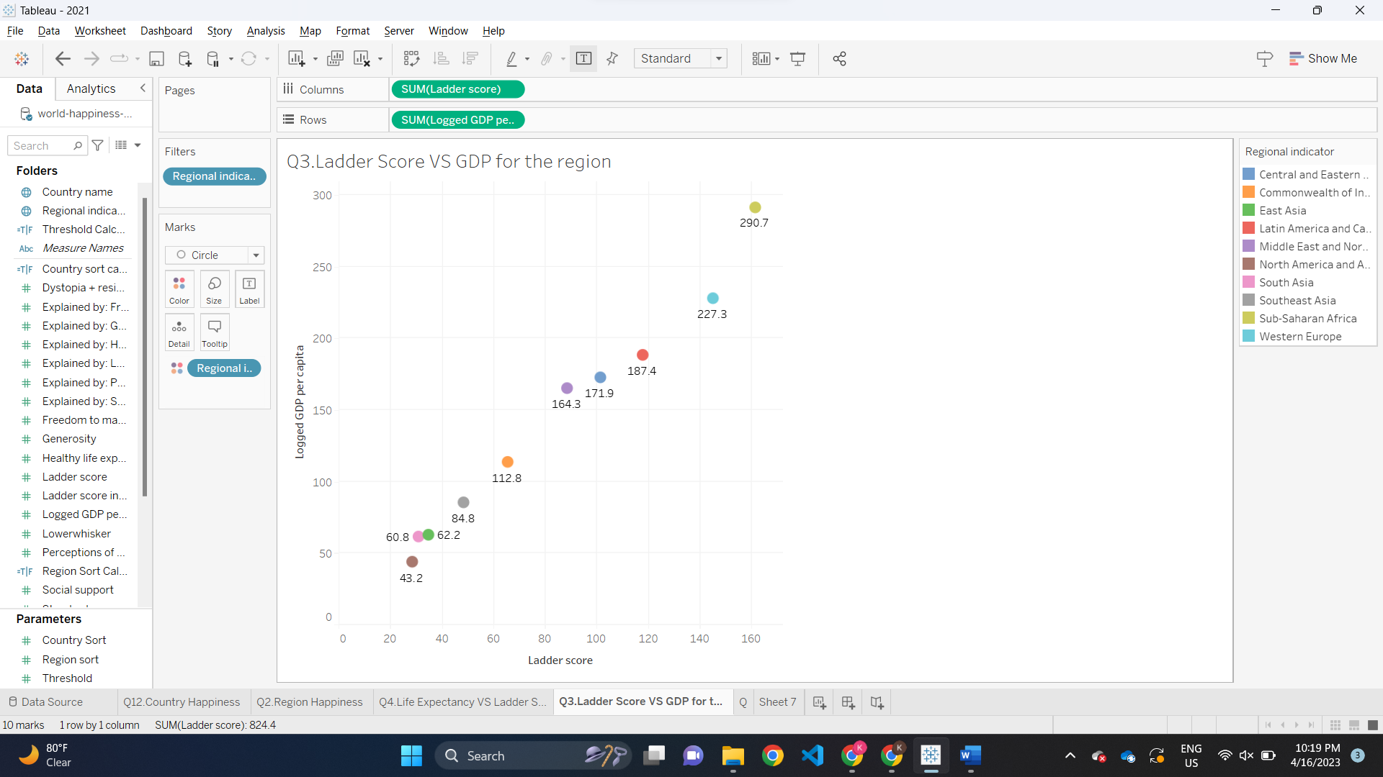

Q4.Trend between life expectancy and happiness across different parts of the reason.

Answer: A scatterplot graph is used to create a trend between different parts of the region based on life expectancy and happiness and it comes out to be more the happiness higher the life expectancy. Pre-attentive are size, shape(circle), color(hue).

Q5. How does the amount of GDP per capita differ among different countries of the world?

Answer: A heat map is used to represent the G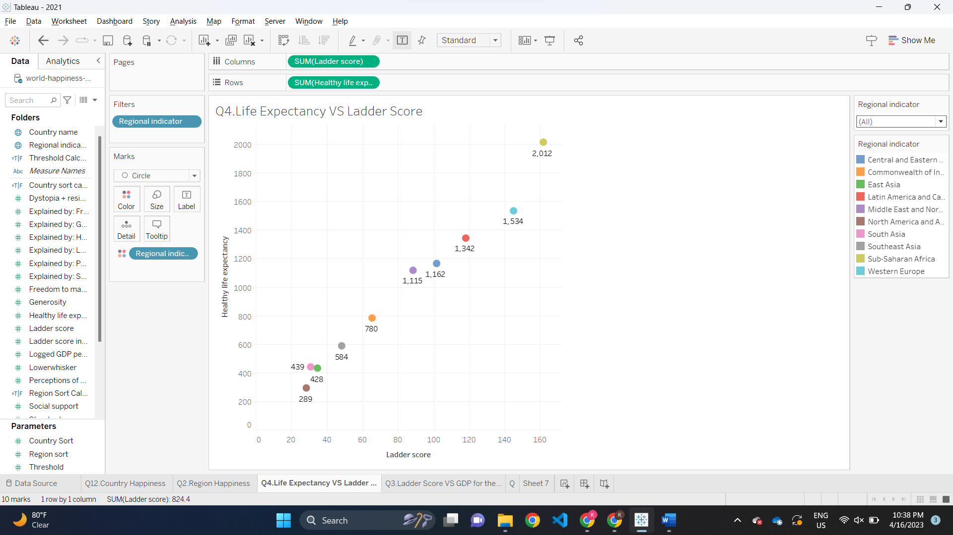DP of the different countries of the world and the light blue color represents the lowest GDP and the dark blue represents the highest GDP all over the world. Pre-attentive are location, color(intensity).

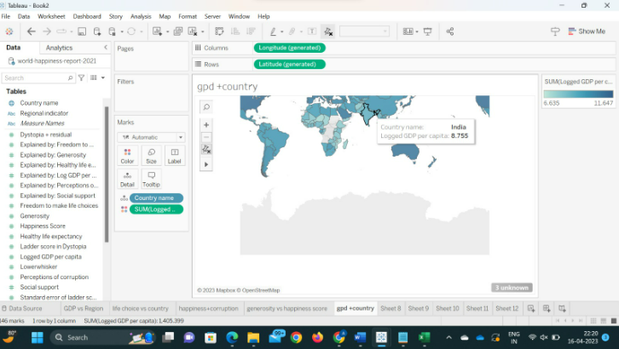

Q6.Show the relation between country and ladder score as per user control.

Answer: A bar chart is used for the visualization where x axis represents country and y axis represent the happiness(ladder score).And a user control is given which is known as threshold which gives the user the control to see which country are above happiness level for the point. Pre-attentive are length, color(hue).

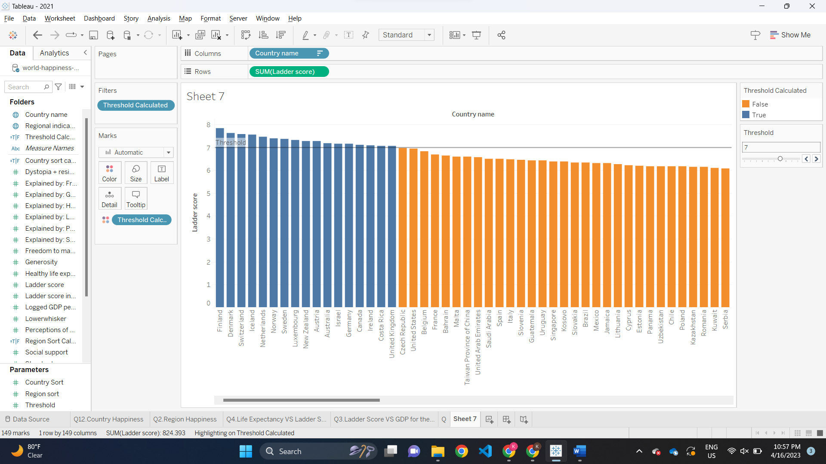

Q7. How does the degree of Freedom to make life decisions vary across different regions of the world?

Answer: It is a bar graph plot for the between the different country and the life choice and over here a user has been given an access to change the region and view the specific region and the country in that region. Pre-attentive are length, color.

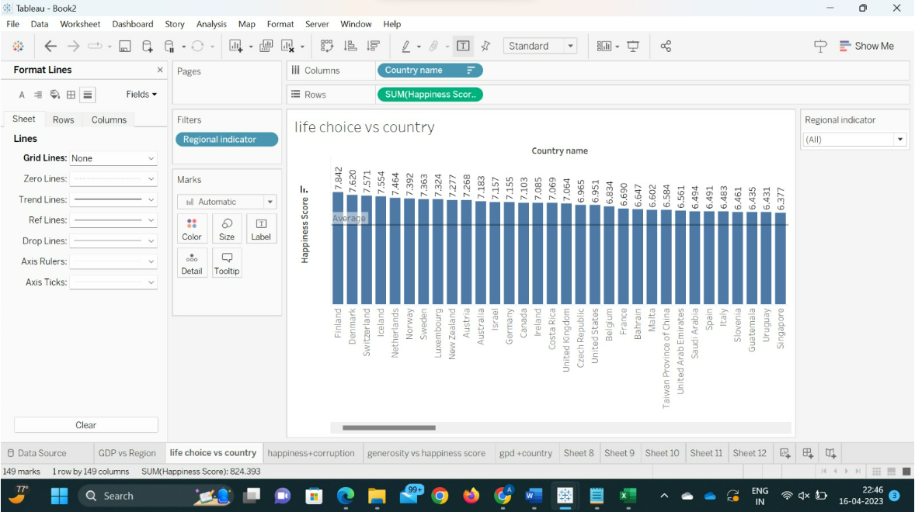

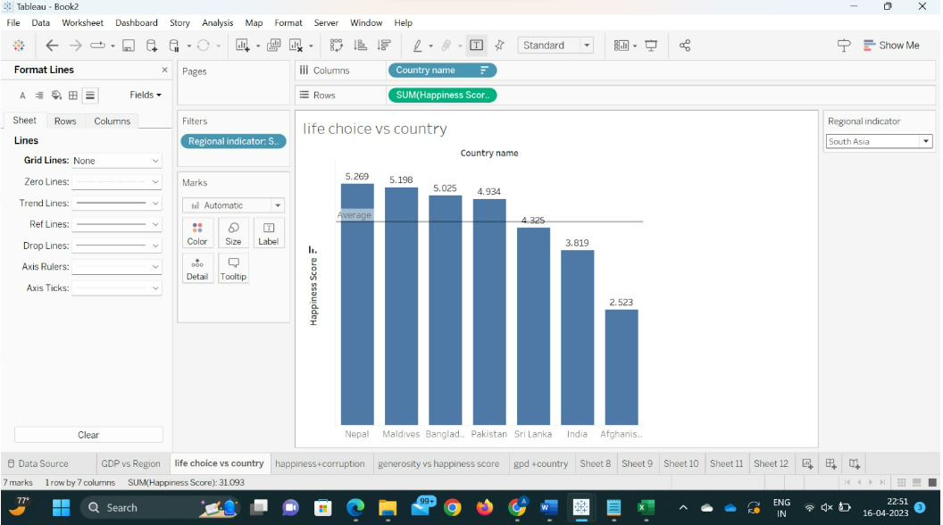

Q8.Difference between social support and explained by: social support along with happiness around the country?

Answer: A multi bar chart is used for this type of visualization where an indirect measure of the impact of social support on the overall happiness score is "explained by social support," whereas "social support" is a direct measure of the perceived availability of social support. Pre-attentive are length, color(hue).

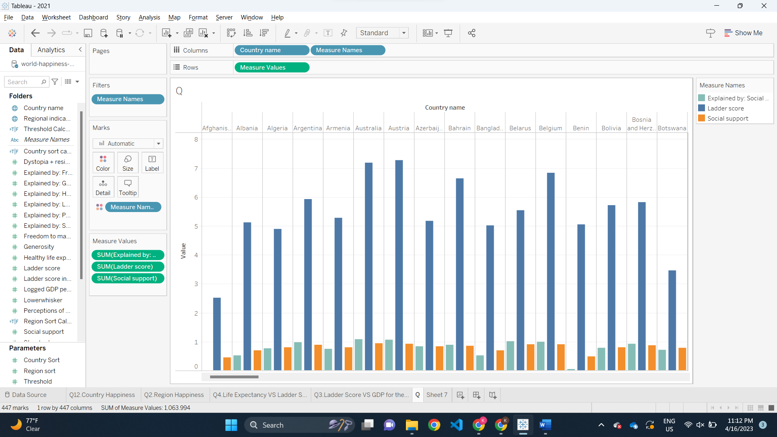

Q9. What is the distribution of the various components (such as social support, GDP per capita, and so on) across all countries in the dataset?

Answer: A stacked bar chart is used to create a visualization of social support, GDP per capita, perception and social support along the country in the other axis. Pre-attentive are length, color(hue).

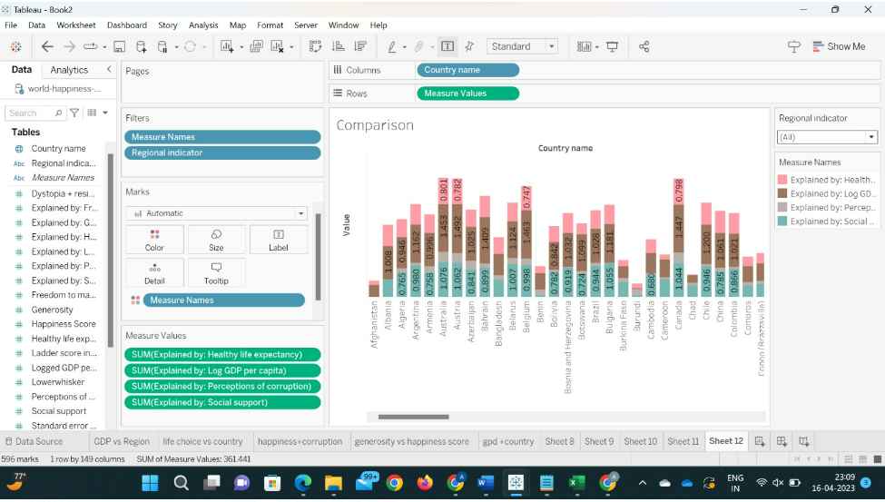

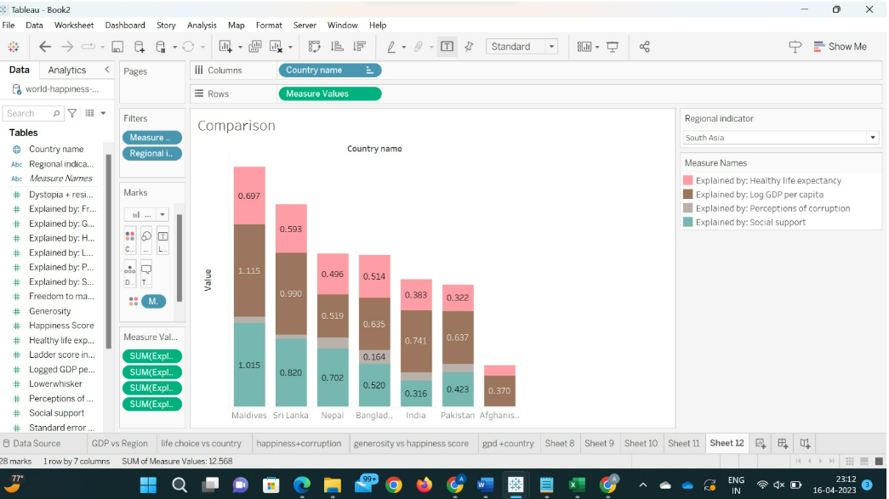

Q10. What correlation exists between social support levels and happiness scores, and which nations have the greatest and lowest levels?

Answer: In this visualization, x axis represents the countries while the y axis shows the values, the stacked bar chart plot would show relationship between social support , explained by social support and ladder score of respective countries. Pre-attentive are length, color(hue).

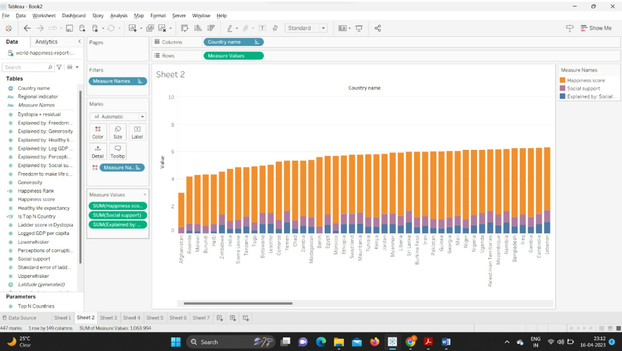

**SECTION 6: INTERACTIVITY**

Tableau provides a plethora of options for users to tailor their dashboards. One such option is to employ parameters, which allow users to choose between measurements, establish sorting criteria, and control display components.

Furthermore, parameters can aid in complex computations. Users can quickly add more variables to their projects by using parameters, which speeds up both data analysis and visualization activities.

Tableau parameters, which allow users to change constants such as integers, dates, or computed fields, can be used to create these variables.

The revised number can then be used in calculations, filters, or reference lines.

Furthermore, parameters, filters, and computed fields can be made interactive in a variety of ways to improve the visual representation of charts and graphs.

Stacked bar chart:

To compare the sums of several categories and see how each category is made up, stacked bar charts are helpful. They may be used to demonstrate how a category is broken down into subcategories and how those subcategories add to the category's total worth.

 Bar chart-

A bar chart is a graphical representation of data that employs equal-width rectangular bars to illustrate numbers from several categories or groupings. The lengths of the bars correspond to the values they indicate, and they can be arranged horizontally or vertically.

 Scatter plot-

Scatter plots can be used to emphasize clusters or groupings of data as well as to detect outliers or strange data points. Furthermore, they may be augmented with extra information such as colors or shapes to indicate a third variable, adding to the visualization's content.

 Heat Map-

Heat maps can also be used to find correlations or links between multiple variables. A heat map, for example, could be used to depict the link between distinct features in a data set, such as the association between GDP and region.

**Interactive controls used in this dashboard:**

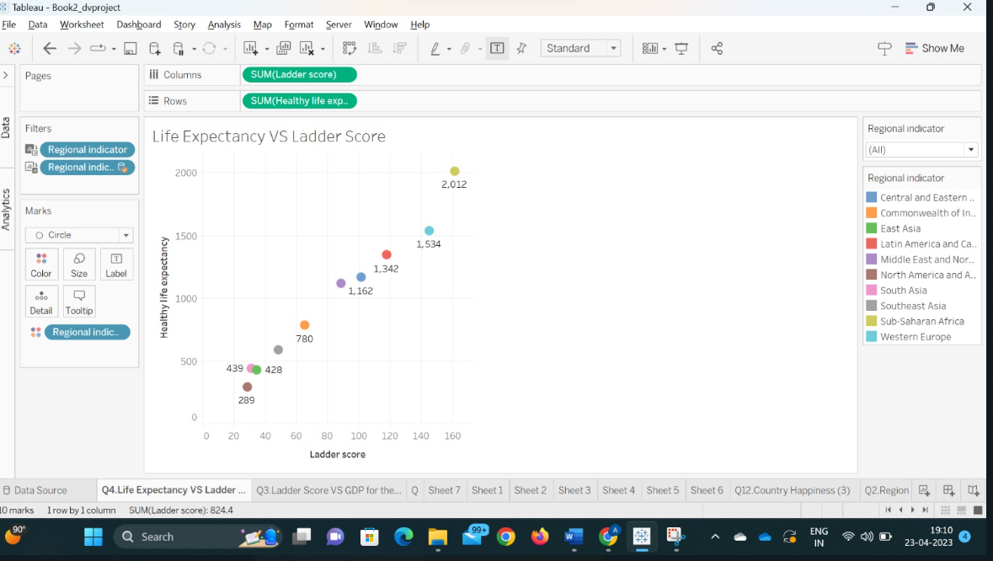

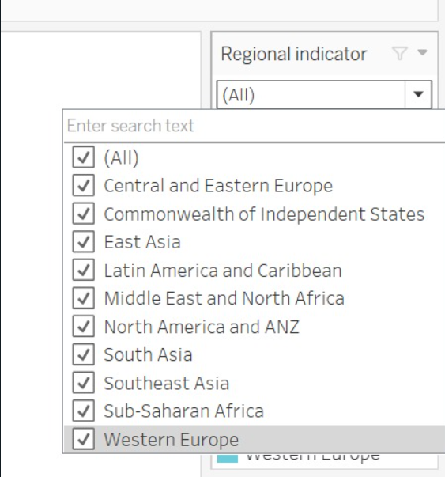

Regional indicator used to view visualization for particular regions

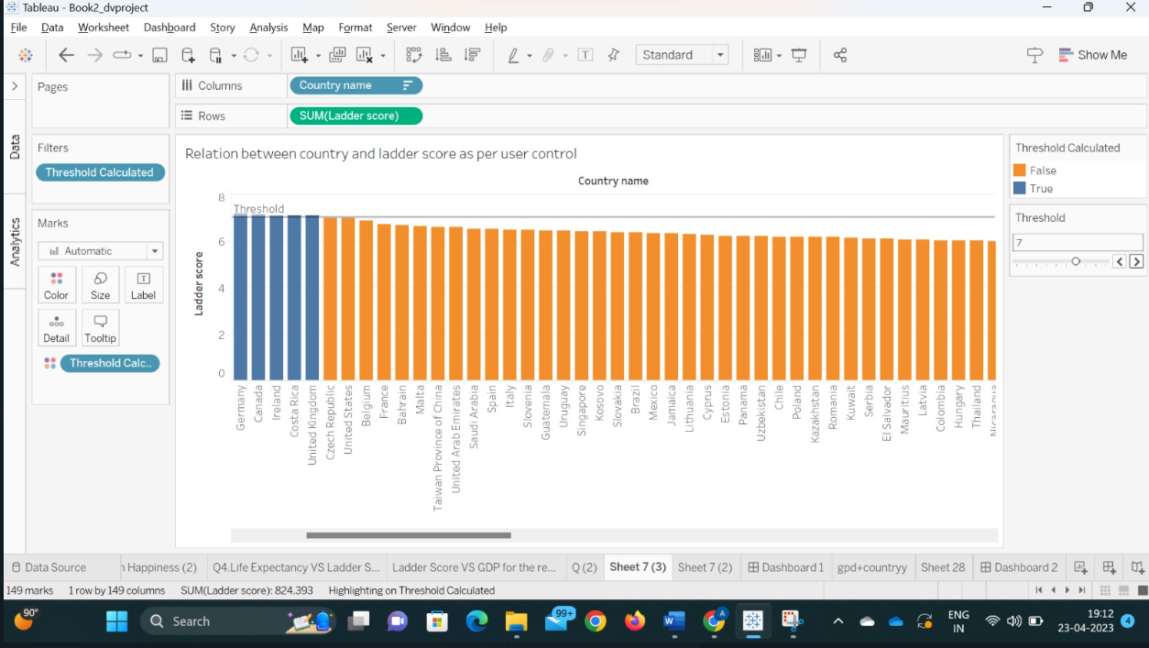

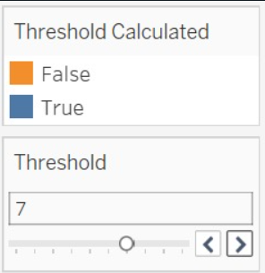

Distinguishing countries on happiness score based on threshold value set by the user

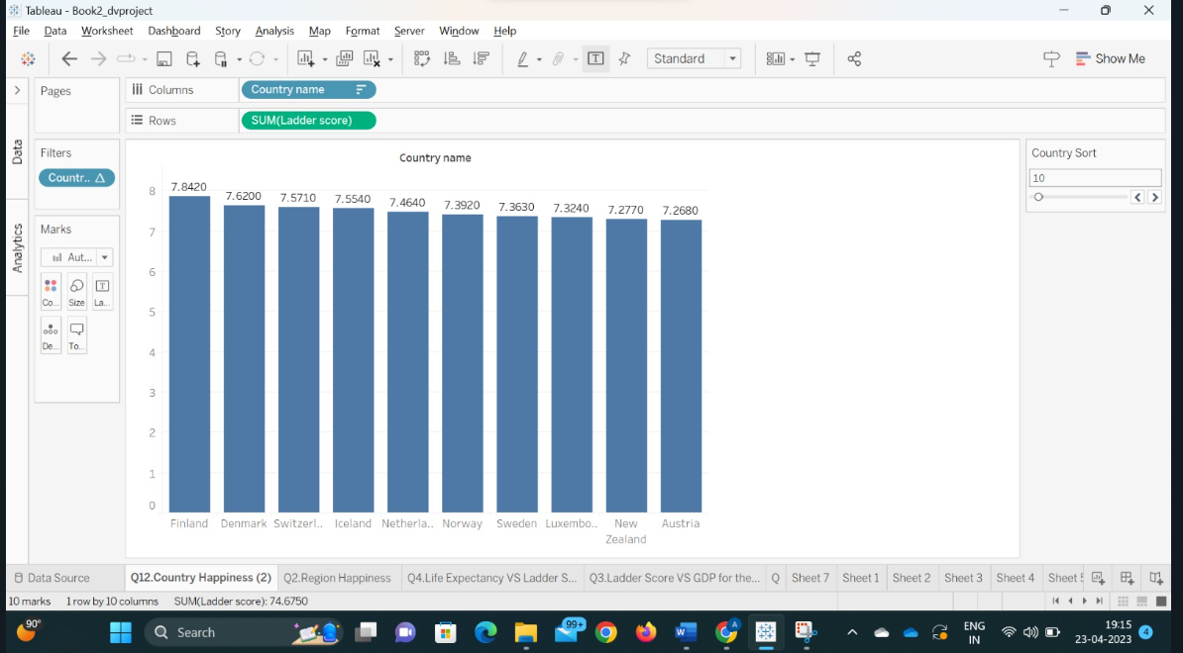

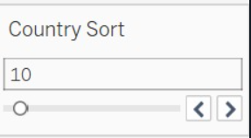

Showing the visualization of happiness score set by the user.

**REFERENCES**

**Tableau Public Dashboard link:** <https://public.tableau.com/views/Book2_dvproject_dashboard1/Dashboard2?:language=en-US&publish=yes&:display_count=n&:origin=viz_share_link>

**Dataset Link:**

<https://www.kaggle.com/datasets/ajaypalsinghlo/world-happiness-report-2021>

**Mural Link:** <https://app.mural.co/t/dvproject9481/m/dvproject9481/1680555895718/e7c4a2e0a1cc713bee70d1d8340a94792764fc81?sender=uf027d170891d0fce20504950>